% EXPERIMENT-1 <<Part-A>>
% Write a program to plot PDF of a Gaussian (Normal) Random Variable for:
% CASE-1 Standard Gaussian: mean = 0 and standard deviation = 1
% CASE-2 General Gaussian: mean = 1 and standard deviation = 1
% CASE-3 General Gaussian: mean = -1 and standard deviation = 1
% CASE-4 General Gaussian: mean = 0 and standard deviation = 1.5
% CASE-5 General Gaussian: mean = 0 and standard deviation = 0.5
% CASE-6 General Gaussian: mean = 1 and standard deviation = 0.5

% Name : Rathod Chittaranjan
% Roll no: 32457
% Batch: L8

% Plotting Cas-1:
m = 0; # Given: mean = 0
sd = 1; # Given: standard deviation = 1
x = -6:0.1:6; # Define suitable range of x values (as per our choice).
y = normpdf(x,m,sd); # Calculate values of Normal PDF for all xs.
# Note: The 'normpdf' function belongs to the statistics package.
# To load the package,run 'pkg load statistics' from the Octave prompt
# in command window before running this program.

figure(1) # Open a figure window named as figure-1.
# We wish to plot all the cases (Total 6 Plots) in the same figure window.
# Use 2 rows & 3 columns so that we have total 6 plots as shown below.
# +-----+-----+-----+
# | 1 | 2 | 3 |
# +-----+-----+-----+
# | 4 | 5 | 6 |
# +-----+-----+-----+
subplot(2,3,1) # The plot (Case-1) will be on location-1 as shown above.
plot(x,y) # To plot Case-1 (y vs x).
axis([-6 6 0 1]); # x-axis ranges from -6 to 6 & y-axis ranges from 0 to 1.
title('CASE-1: mean=0, std dev=1') # Title of the plot
xlabel('x values----->');
ylabel('PDF--->');
grid on;

% Plotting Case-2:
% Write the code yourself to plot Case-2 on Location-2 with given mean and
% standard deviation.
m = 1; # Given: mean = 1
sd = 1; # Given: standard deviation = 1
x = -6:0.1:6; # Define suitable range of x values (as per our choice).
y = normpdf(x,m,sd); # Calculate values of Normal PDF for all xs.
figure(2) # Open a figure window named as figure-1.
subplot(2,3,1) # The plot (Case-2) will be on location-1 as shown above.
plot(x,y) # To plot Case-2 (y vs x).
axis([-6 6 0 1]); # x-axis ranges from -6 to 6 & y-axis ranges from 0 to 1.
title('CASE-1: mean=1, std dev=1') # Title of the plot
xlabel('x values----->');
ylabel('PDF--->');
grid on;

% Plotting Case-3:
% Write the code yourself to plot Case-3 on Location-3 with given mean and
% standard deviation.
m = -1; # Given: mean = -1
sd = 1; # Given: standard deviation = 1
x = -6:0.1:6; # Define suitable range of x values (as per our choice).
y = normpdf(x,m,sd); # Calculate values of Normal PDF for all xs.
figure(3) # Open a figure window named as figure-1.
subplot(2,3,1) # The plot (Case-3) will be on location-1 as shown above.
plot(x,y) # To plot Case-3 (y vs x).
axis([-6 6 0 1]); # x-axis ranges from -6 to 6 & y-axis ranges from 0 to 1.
title('CASE-1: mean=-1, std dev=1') # Title of the plot
xlabel('x values----->');
ylabel('PDF--->');
grid on;

% Plotting Case-4:
% Write the code yourself to plot Case-4 on Location-4 with given mean and
% standard deviation.
m = 0; # Given: mean = 0
sd = 1.5; # Given: standard deviation = 1.5
x = -6:0.1:6; # Define suitable range of x values (as per our choice).
y = normpdf(x,m,sd); # Calculate values of Normal PDF for all xs.
figure(4) # Open a figure window named as figure-1.
subplot(2,3,1) # The plot (Case-1) will be on location-1 as shown above.
plot(x,y) # To plot Case-4 (y vs x).
axis([-6 6 0 1]); # x-axis ranges from -6 to 6 & y-axis ranges from 0 to 1.
title('CASE-1: mean=0, std dev=1.5') # Title of the plot
xlabel('x values----->');
ylabel('PDF--->');
grid on;

% Plotting Case-5:
% Write the code yourself to plot Case-5 on Location-5 with given mean and
% standard deviation.
m = 0; # Given: mean = 0
sd = 0.5; # Given: standard deviation = 0.5
x = -6:0.1:6; # Define suitable range of x values (as per our choice).
y = normpdf(x,m,sd); # Calculate values of Normal PDF for all xs.
figure(5) # Open a figure window named as figure-1.
subplot(2,3,1) # The plot (Case-1) will be on location-1 as shown above.
plot(x,y) # To plot Case-5 (y vs x).
axis([-6 6 0 1]); # x-axis ranges from -6 to 6 & y-axis ranges from 0 to 1.
title('CASE-1: mean=0, std dev=0.5') # Title of the plot
xlabel('x values----->');
ylabel('PDF--->');
grid on;

% Plotting Case-6:
% Write the code yourself to plot Case-6 on Location-6 with given mean and
% standard deviation.
m = 1; # Given: mean = 1
sd = 0.5; # Given: standard deviation = 0.5
x = -6:0.1:6; # Define suitable range of x values (as per our choice).
y = normpdf(x,m,sd); # Calculate values of Normal PDF for all xs.
figure(6) # Open a figure window named as figure-1.
subplot(2,3,1) # The plot (Case-6) will be on location-1 as shown above.
plot(x,y) # To plot Case-1 (y vs x).
axis([-6 6 0 1]); # x-axis ranges from -6 to 6 & y-axis ranges from 0 to 1.
title('CASE-1: mean=1, std dev=0.5') # Title of the plot
xlabel('x values----->');
ylabel('PDF--->');
grid on;

% Compare Case-1, 2 and 3: Observe the effect of mean in terms of Position,
% Width and Height.

% Compare Case-1, 4 and 5: Observe the effect of standard deviation in terms of
% Position, Width and Height.

% Compare Case-1 and 6: Observe the effect of both mean and standard deviation
% in terms of Position, Width and Height.

OUTPUT:

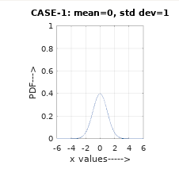
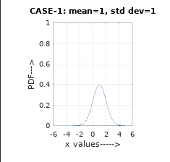
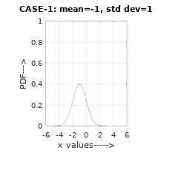

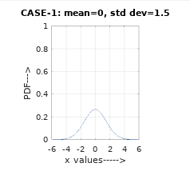
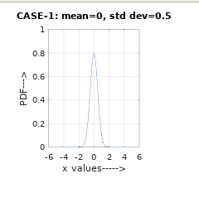
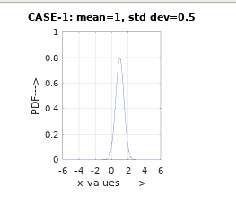

% EXPERIMENT-1 <<Part-B>>
% Write a Program to plot PSD and Autocorrelation of a White Gaussian Random
% Process

y=normrnd(0,1,1,200);
Gy=periodogram(y);
Ry=abs(ifft(Gy,256));
Ry=[Ry(130:256)' Ry(1:129)']
t=-127:1:128;
figure
subplot(1,2,1)
plot(Gy)
xlabel('frequencysamples');
title('PSD')
subplot(1,2,2)
stem(t,Ry)
xlabel('time shift')
title('autocorrelation')

OUTPUT:

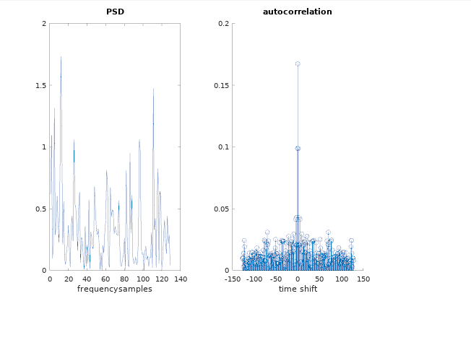

Conclusion :
Effect of mean and standard deviation in terms of the position, width and height of the
graph was observed by comparing various cases . Autocorrelation of the white
gaussian process was also plotted in octave software.

